Controller Design and Integration

Vincent Martin
TUID: 913012274
ECE 2613
Lab #: 9 and 10 (11/8/2012)

Introduction:
The objective of this lab is to create three new modules consisting of a clear/start/stop controller, a debouncer controller and finally a stop watch controller which will include instantiations of both the clear/start/stop and debouncer controller.

These created modules will be put together with previous modules created in previous labs to create a working stopwatch. The previous modules include the sw_core, sw_ctrl, ctr_blk, dsp_drvr, svn_seg_decoder, counter_0to9, counter_0to5 and finally the divideby100 module.

This lab will be the ultimate test of our previous work and will give the best demonstration of code reuse and instantiation to date.

Applying the Theory to Block Diagrams:
To best understand the modules that will be involved in our design it is good to look at block diagrams of our controllers. Included below are block diagrams for our css_ctrl module, dbnc_ctrl and the sw_ctrl module that includes them.

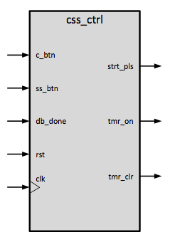
clear/start/stop controller css_ctrl.v

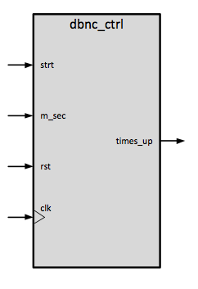
debouncer controller dbnc_ctrl.v

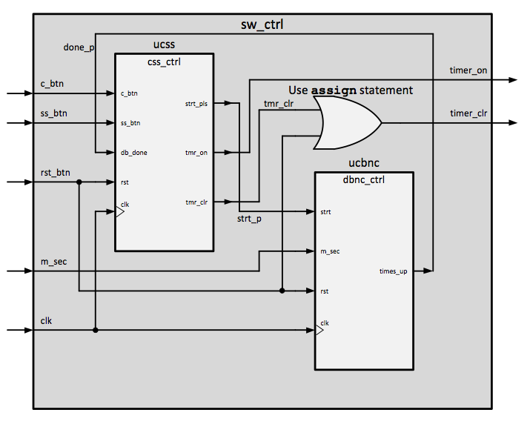

stop watch controller sw_ctrl.v

Additionally we will want to implement a testing module. This scheme will utilize a number of .txt files, which will allow us to test all of our expected outcomes for our design.

Procedures:
Import the source code from previous labs
- Connect to the design server using no machine
- Execute XISE
- Open the lab9_10 project in ~/xilinx/lab9_10
- Add copies of the following files taken from your previous lab files
  - sw_core.v
  - dsp_drvr.v
  - svn_seg_decoder.v
  - 2612_lab7.ucf
  - counter_0to9.v
  - counter_0to5.v

Create the css_ctrl module
- Create a css_ctrl.v file using the new source wizard to give it the following input/output settings
  - input c_btn
  - input ss_btn
  - input rst
  - input clk
  - output reg strt_pls,
  - output reg tmr_on,
  - output reg tmr_clr

- Create the logic that will cause css_ctrl to behave as seen below in the state diagram. 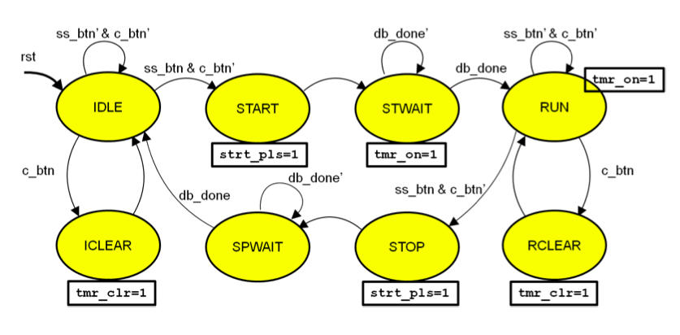
- Simulate the created module with tb_css_ctrl correcting any mismatches.

Create the dbnc_ctrl module
- Create a dbnc_ctrl.v file using the new source wizard to give it the following input/output and internal register settings
  - input strt,
  - input m_sec,
  - input rst,
  - input clk,
  - output reg times_up
  - reg [8:0] millisecond_count
  - reg [8:0] next_millisecond_count

- Create the logic that will cause dbnc_ctrl to behave as seen below in the state diagram.
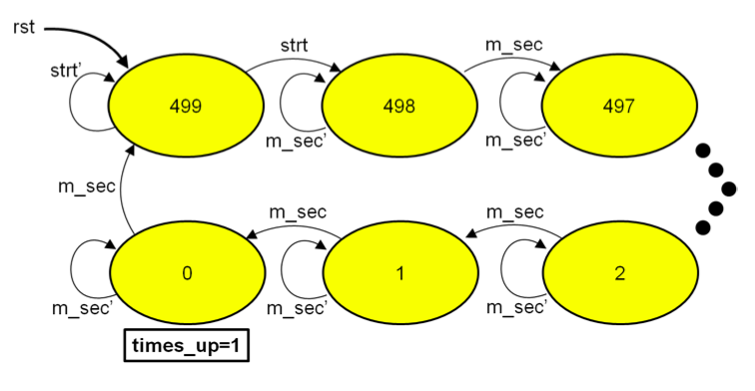
3. Simulate the created module with tb_dbnc_ctrl and correct any found mismatches.

Create the sw_ctrl module
- Create a sw_ctrl.v file using the new source wizard to give it the following input/output settings
  - input c_btn,
  - input ss_btn,
  - input rst_btn,
  - input m_sec,
  - input clk,
  - output timer_on,
  - output timer_clr

- Create the following wires
  - done_p
  - tmr_clr
  - strt_p

3. Instantiate the two modules into sw_ctrl with the following connections
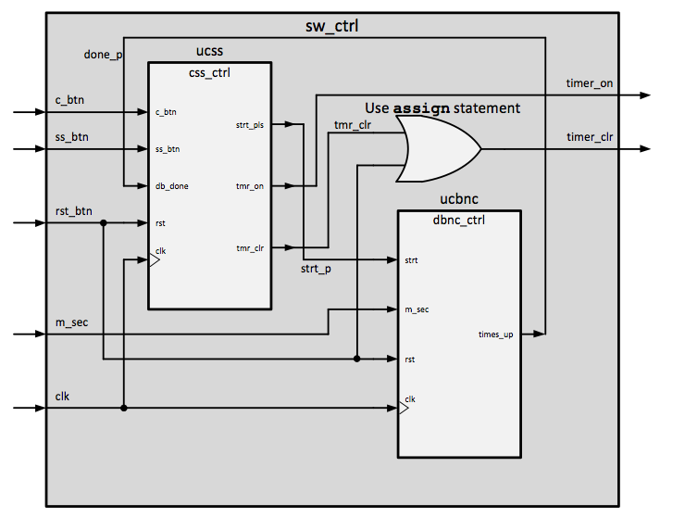

- Create an assign statement for the timer_clr output as seen above.
- Simulate the created module with tb_sw_ctrl and correct any found mismatches.

Instantiate all of the above into the sw_core module

Compile to .bit file
- Compile to a .bit file by navigating to
  - Implementation
    - Xc3s500-e4g320
      - Lab7_top_io_wrapper (didn’t rename)
        - Implement design
        - Generate programming file

Transfer .bit file to board
- Use use your favorite network transfer program to move the .bit file from the development server to your local workstation
- Plug the boar into the USB board
- Launch Digilent Adept application
- Click config tab
- Click on browse by PROM icon
- Select your .bit file
- Click Program
- Reset board to test

Results:
Below is iSim output from an input of the design simulation of tb_sw_core which appears to have worked properly and as expected.

Output from simulation of tb_sw_core:

ISim O.76xd (signature 0x8ddf5b5d)
This is a Full version of ISim.
WARNING: For instance udd/U1/, width 1 of formal port display_on is not equal to width 32 of actual constant.
Time resolution is 1 ps
Simulator is doing circuit initialization process.
Finished circuit initialization process.
ISim> run all
digit0 changed to: 1001111 - time: 100000020 ns
digit0 changed to: 0100100 - time: 200000020 ns
digit0 changed to: 0000110 - time: 200002020 ns
digit0 changed to: 0001011 - time: 200004020 ns
digit0 changed to: 0010010 - time: 200006020 ns
digit0 changed to: 0010000 - time: 200008020 ns
digit0 changed to: 1000111 - time: 200010020 ns
digit0 changed to: 0000000 - time: 200012020 ns
digit0 changed to: 0000010 - time: 200014020 ns
digit0 changed to: 1000000 - time: 200016020 ns
digit1 changed to: 1001111 - time: 200016040 ns
digit1 changed to: 0100100 - time: 200036040 ns
digit1 changed to: 0000110 - time: 200056040 ns
digit1 changed to: 0001011 - time: 200076040 ns
digit1 changed to: 0010010 - time: 200096040 ns
digit1 changed to: 0010000 - time: 200116040 ns
digit1 changed to: 1000111 - time: 200136040 ns
digit1 changed to: 0000000 - time: 200156040 ns
digit1 changed to: 0000010 - time: 200176040 ns
digit1 changed to: 1000000 - time: 200196040 ns
digit2 changed - to 1001111 - time = 200196060 ns
digit2 changed - to 0100100 - time = 200396060 ns
digit2 changed - to 0000110 - time = 200596060 ns
digit2 changed - to 0001011 - time = 200796060 ns
digit2 changed - to 0010010 - time = 200996060 ns
digit2 changed - to 1000000 - time = 201196060 ns
digit3 changed - to 1001111 - time = 201196080 ns
digit3 changed - to 0100100 - time = 202396080 ns
digit3 changed - to 0000110 - time = 203596080 ns
digit3 changed - to 0001011 - time = 204796080 ns
digit3 changed - to 0010010 - time = 205996080 ns
digit3 changed - to 0010000 - time = 207196080 ns
digit3 changed - to 1000111 - time = 208396080 ns
digit3 changed - to 0000000 - time = 209596080 ns
digit3 changed - to 0000010 - time = 210796080 ns
Simulation complete!!!

Results on board
Once the .bit file was transferred to the board I was able to see that I could reset and hold the counter. This works as expected.

Discussion:
This lab was exciting for me because it showed me in a more realistic way how all of our theory can be useful. Now we are left with a project that is more complete. I can now actually show someone that I made a partial stop watch which is pretty cool.

It was also interesting to note how the testing was completed in this lab. If we were to go ahead and test every permutation of the clock in the iSim simulator it would take a very long time. Instead we did a small hack so that the testing did not take as long. This is good that it saves us quite a bit of time.

Finally, as always, this lab allowed me to make quite a few mistakes and learn from them. The first mistake that cost me was that I accidentally made the wires 1 bit instead of 4 bit busses. This caused me all sorts of problems. Additionally I did not wire up all the modules correctly the first time. This also cost me some time. Surely this teaches me to be more careful in the future when I’m doing this sort of thing, especially with regards to design block diagrams.

Source Code:

